
The British College
KATHMANDU
Coursework Submission Coversheet
(individual coursework only)
Faculty of Arts, Environment and Technology LBU Student Id:
C7466889
For checking by the student:
Please ensure all information is complete and correct and attach this form securely to the front of your work before posting it in a coursework collection box.
Award name: Bsc Hons in Computing
Module code: 15781-AUT-202110
Module name: Advance Database System (ADS)
Module run: 2025
Coursework title: Data warehouse Design and Development
Due Date: January 13, 2026 A.D
Module leader: (In LBU): Jackie Campbell, Sanela Lazarevski
Module tutor: (In TBC): Dibya Tara Shakya
TURNITIN Checked: YES NO (please circle)

Submission date& time: Date: 13/1/2026 Time: At night
Total Word Count: Total Number of Pages (including this front sheet):
In submitting this form with your assignment, you make the following declaration:
I declare, that the coursework submitted is my own work and has not (either in whole or part) been submitted towards the award of any other qualification either at LBU or elsewhere. I have fully attributed/referenced all sources of information used during the completion of my assignment, and I am aware that failure to do so constitutes an assessment offence.
Signed: Ojaswi Shrestha Date: 2026-1-13
You are strongly advised to retain a second copy of your work in case of any query about the assignment.

For completion by the faculty:
This mark is provisional and subject to moderation and approval by the relevant examining board
Teacher's Feedback

Teacher's Signature: __________________________________ Date: _________________

Introduction
In previous database assignment part 1, there were 2 data sources from PRCS and PS_WALES of police department from which needed columns from each table of both data sources were extracted. Data preparation is the process of cleaning, transforming and arranging raw data for analysis. From the selected attributes from data sources, staging tables were made to keep it ready for cleansing process then they are separated into good and bad data. Further on, the bad data were changed into good data and then finally loaded into the dimension and fact tables. All this process is called ETL process also known as Extraction, Transformation and Loading.
In this assignment part 2, previous fact and dimension tables are now used to create various reports and charts from which meaningful insight can be built for the betterment of police departments. Data analytics consist of examining, modeling and interpreting arranged data to extract meaningful insights. Business Intelligence (BI) is the process of collecting, arranging and visualizing data to support decision-making. In context of crime analysis, BI tools and techniques can help officers and investigators to identify crime trends, hotspot areas and frequently occurring crimes and allowing them to allocate resources from visual reports and charts. BI converts raw data into charts, reports and interactive dashboards which make complex patterns provided by data easy to understand.
In this overall project, Data Preparation, Business Intelligence and Data Analytics are combined to transform raw crime data into meaningful insights. With thorough extraction, cleaning and visualization, officers and investigators can spot high crime rate areas, understand crime patterns and prioritize resource allocation to decrease the crime rate efficiently.

Excel

Crime Severity Risk Index by Area and Year
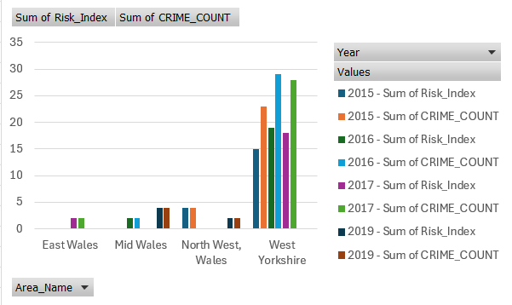
Fig 1: Crime Severity Risk Index by Region and Year
Chart Explanation
The above shown diagram is a clustered column chart which shows the total number of crimes happening in each area and year with their RISK INDEX. Risk index is a numerical measure which shows how risky a crime situation is in each area. It is calculated as:
Risk Index= [(is_escalated_flag*2)+(1-is_closed_flag)] / total sum of crimes
- is_escalated = 0 or 1
- is_closed = 0 or 1
- 1 - is_closed = converts closed flag into open flag (1 if open, 0 if closed)
- Multiply escalated by 2 → gives more weight to serious crimes
- Divide by total number of crimes = normalizes the score per region/year
The chart shows the highest amount of crime and higher crime severity area is West Yorkshire and lowest being East, Mid, and Northwest Wales meaning West Yorkshire requires more investigation and deployment of resources.
How the Chart or Report helps the Police and Crime Investigation
- Distribution of Resources:
Each area with high amount of risk index should be targeted to increase daily patrols, investigations, and mitigating the crime issues by deploying more numbers of police officers, equipment and other resources.

- Making decisions based on data:
The investigation department or officers will be able to focus on crimes which have high severity risk instead of just investigating places with high number of crimes.

- Trend Analysis of Crime Severity:
With the visual representation of risk index over months and years, officers will be able to identify whether the crime severity is getting better or just worsening from which they should get margin idea on which areas to focus.

Crime Growth vs Resolution Gap Analysis
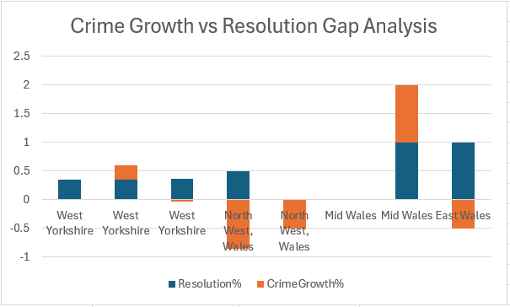
Fig 2: Crime Growth vs Resolution Gap Analysis
Chart Explanation
The above shown diagram is a stacked column chart which represents the crime growth percentage with their resolution rate for each area of every year. In the above chart, resolution is the crime status in Boolean values in which open, escalate and unknown cases are 1 whereas closed being 0. The orange bar chart is crime growth for each area every year, similarly blue bar is the crime resolution rate. We can also derive that Northwest Wales has the least crime growth rate and East and Mid Wales have similar high crime resolution rate compared to others.
Resolution%= (crimes_reported-unresolved crime)/ crimes_reported
CrimeGrowth%=(current year crime reported – previous year crime reported)/ previous year crime reported
How the Chart or Report helps the Police and Crime Investigation
- Identification of problematic areas:
Small or no blue stacks on a positive scale indicate places with low crime resolution rate. The chart aids in setting priorities for resources, like as additional police, special units, or investigation focus.

- Examine the rise in crime over time:
Large orange stack represents the high crime growth on a positive scale from which we can examine whether the resolution rate is keeping up with crime increasing rate as time goes by.

- Identify trends by area:
From the help of chart, it shows each area’s crime and resolution rate by year. With year analysis, it can be visualized the increase or decrease of crime rate and whether the resolution rate for particular crime rate is working or not.

Trend of Monthly Crime Type
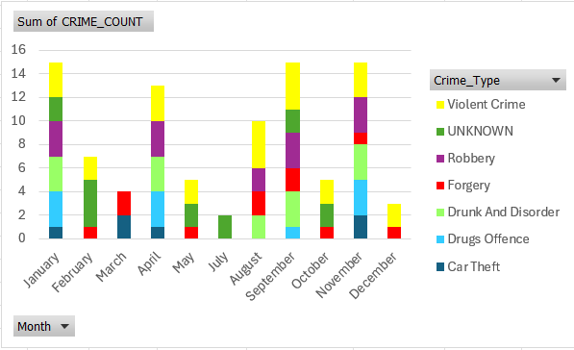
Fig 3: Trend of Monthly Crime Type
Chart Explanation
The above figure represents the monthly crime patterns for various crime types in a stacked bar chart where each bar represents a month in different color segments. The overall height of bar shows total crime rates each month. The yellow segment depicting Violent crime is most common in each month all year round whereas Car theft being the least common.
How the Chart or Report helps the Police and Crime Investigation
- Preventive Strategy Design:
By studying chart, it will help to schedule crime prevention activities on the basis of type of crime happening from past monthly trends.

- Crime Type Prioritization:
The chart reveals which kind of crime types support the most to monthly spikes of crimes and by providing investigators knowledge on which crime type happens most will help to decrease crime.

- Monthly Demand Prediction:
It will help to identify the month with large amount of crime pressure put on to officers and enables them to do future planning accordingly.

Police Station Workload Stress
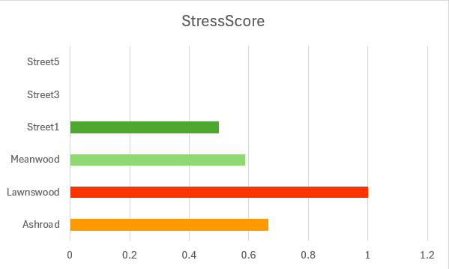
Fig 4: Police Station Workload Stress
Chart Explanation
The above horizontal bar chart shows stations on Y axis and stress score rate on X axis. Stress is calculated as unresolved cases (open, escalate, unknown) by total number of crimes in which green color represents low stress whereas red being higher stress score. In the chart, it’s clear that Lawnswood station is highly stressed with many unresolved cases and Street 3 and 5 have none at all.
How the Chart or Report helps the Police and Crime Investigation
- Identify Overloaded Stations:
Stations which are struggling with unsolved cases can be recognized by investigators and through which they can allocate more officers, detectives and other staff.

- Comparisons and improvements:
By comparing stations from different areas on the basis of crime types and time period can help to identify better ways to improve crime prevention.

- Prioritize Investigations:
Stations with higher stress scores will be able to get immediate attention which will prevent crimes escalating.

Crime Frequency by Area and Crime Type
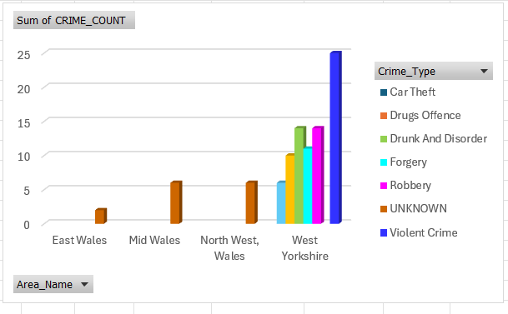
Fig 5: Crime Frequency by Area and Crime Type
Chart Explanation
The above chart shows number of crimes occurred at each area on the basis of their crime type. Y axis represents total crimes; X axis shows the areas and colored bars represent the crime type. Here, the chart shows that mostly in other areas the crime type is unknown whereas there is variety of crime types in west Yorkshire including Violent Crime as highest in numbers.
How the Chart or Report helps the Police and Crime Investigation
- Identification of crime type with higher number of crimes:
The most repeated crime type in each area can be seen and can be differentiated by how taller each bar is. From these police can further allocate the type of staff which are better at investigating certain types of crime.
- Area comparison for certain crime types:
Investigators will be able to determine which areas have higher amount of certain crime type by looking at large bars of each type. Scheduling the patrol for each area at peak hours can help lower crimes.

- Monitoring crime trends over time:
By repeating the chart for every year, investigators will be able to notice changes in crime frequency and also detect upcoming hot spots for crimes.

APEX ORACLE

APEX Crime Analysis Dashboard
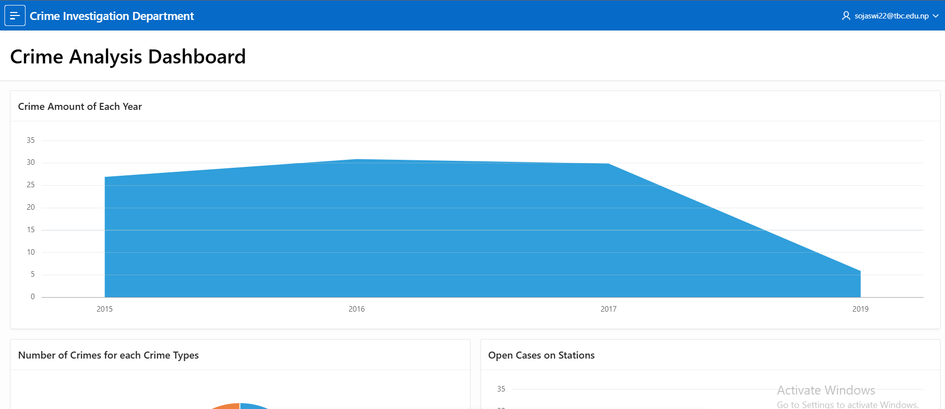
Fig 6: Crime analysis Dashboard (1)
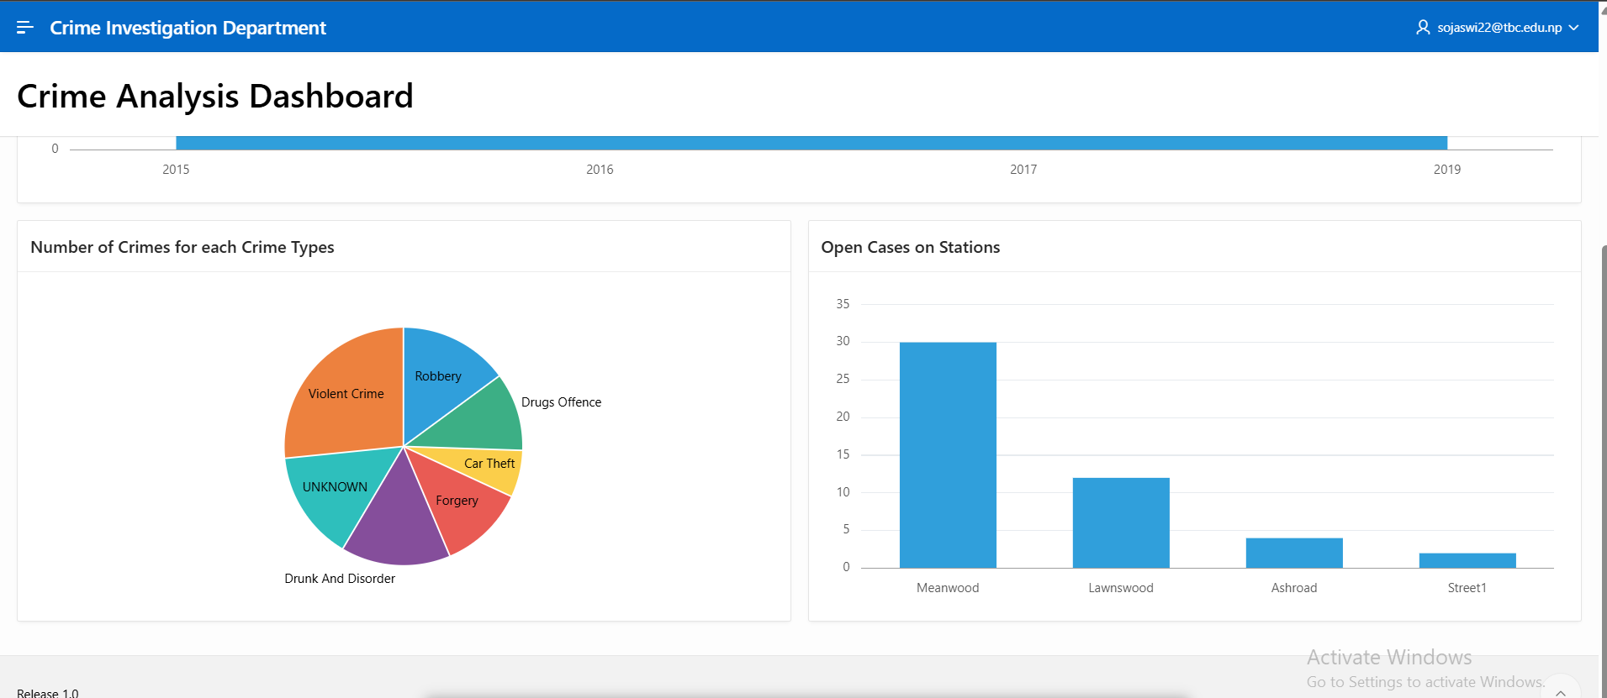
Fig 7: Crime analysis Dashboard (2)

Number of Crimes per Station
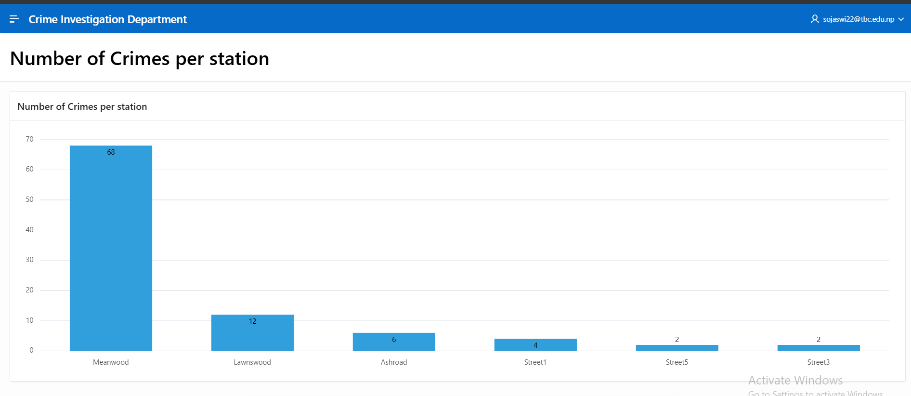
Fig 8: Number of Crimes per Station
Chart Explanation
The above shown vertical chart represents the occurrence of crimes at each police station, which makes it easier to compare the crime volume across various locations. The taller the bar, higher the number of crimes reported at that police station or vice versa. From the chart, Meanwood station is packed with high numbers of crimes and Street 5 and 3 have less numbers of crimes.
How the Chart or Report helps the Police and Crime Investigation
- Performance Evaluation:
The charts allow officers or investigators to evaluate performance of each station by comparing the number of crimes before and after various policy implementation. Continuous increment or decrement of crimes will help to identify the proper strategy to be used in stations.

- Early Risk Identification:
Police stations with unexpected growth of crimes would be a priority and targeted as emerging risk areas which enables faster investigation before crimes escalate or increase in number.

- Community Safety Prioritization:
It can help officers to identify communities mostly affected by crimes and prioritize public safety which helps to improve trust by showcasing that safety decisions are made based on real data analysis.

Open Cases in Each Station
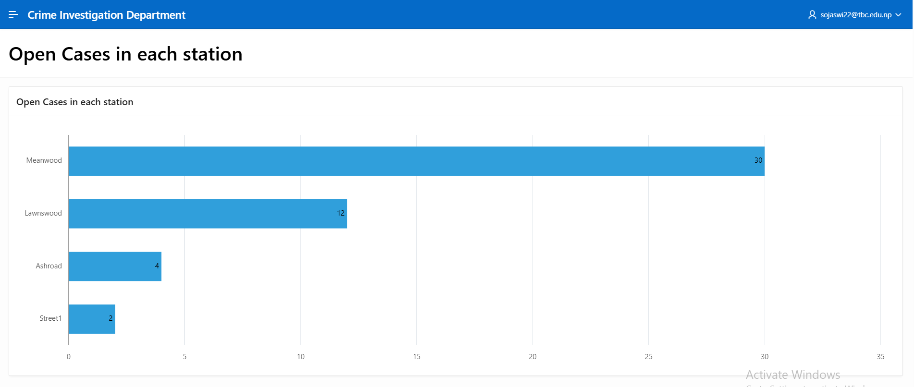
Fig 9: Number of Open Cases in Every Station
Chart Explanation
The above horizontal bar chart depicts a clear comparison of number of open cases for every police station which makes it easy to compare investigation workloads on all stations. Longer bars represent high number of unresolved cases. From the chart, Meanwood station is packed with high numbers of open crime cases and Street 1 has less numbers of open crimes.
How the Chart or Report helps the Police and Crime Investigation
- Investigation Workload Check:
The chart draws attention to stations with high numbers of unresolved open cases which also gives a sign of increased investigation pressure. In order to balance the workload, relocation of cases and providing more human resources can be done.

- Case Resolution Efficiency:
Officers can determine which stations are handling cases effectively and which are having problems by evaluating changes over time. Long-term delays can be a huge sign of resource scarcity or legal difficulties.

- Policy and Procedure Improvement:
The report allows the assessment of investigation policies at every station and insights from report help to reinforce the policy to reduce case delays and improve the case clearance rate.

Common Crime Types
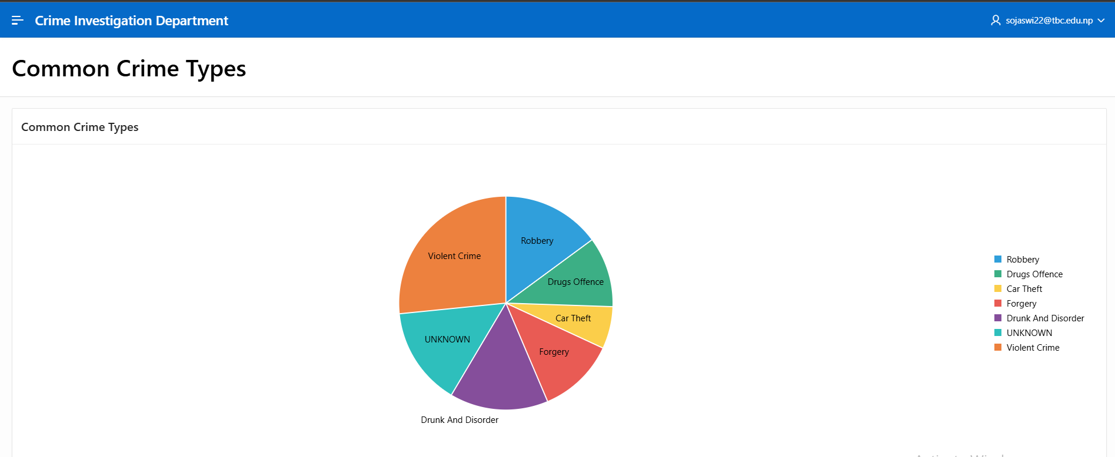
Fig 10: Crime Type Frequency
Chart Explanation
The above pie chart shows how total number of crimes is spread across various varieties of crime categories. Each slice from pie chart depicts the amount of crime of a certain crime type. The orange slice indicating Violent Crime Type is highest in number and yellow slice representing Car Theft is least in number.
How the Chart or Report helps the Police and Crime Investigation
- Crime Type Prioritization:
The report helps officers to spot which crime type takes up the largest share of higher crime rate. This analysis allows focused prevention strategies on the most ruling offenses.

- Special Force Deployment:
It allows effective utilization of special units like violent crime squads, drug units etcetera for dominating crime categories. In the chart, larger slices of pie chart show crime types in much need of attention.

- Public Awareness:
The simple visual pie chart makes it convenient to describe crime patterns to stakeholders or even general public, which reflects transparency in data analysis and makes public involvement convenient.

Monthly Crime Pattern
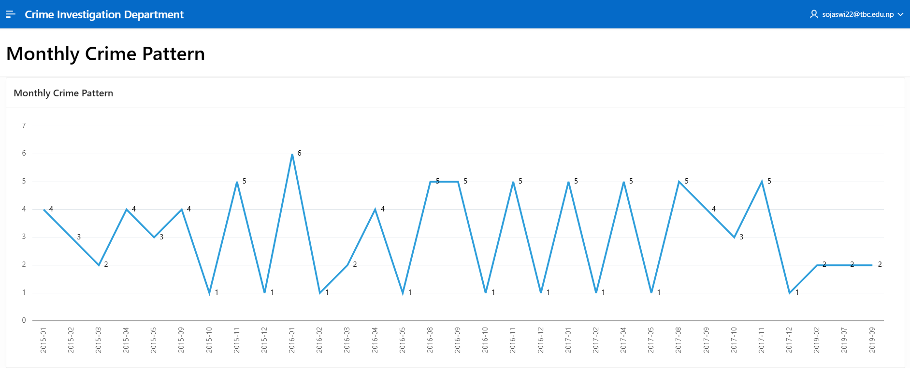
Fig 11: Monthly Crime Pattern
Chart Explanation:
The given line graph offers numbers of crimes reported each month across multiple years, clearly displaying how crime numbers rise or fall over time. High peaks represent high crime periods whereas low dips indicate low crime activity in the month. The highest peak in January 2016 represents large crime numbers in comparison to other months whereas multiple months with low dips shows only 1 crime each month.
How the Chart or Report helps the Police and Crime Investigation
- Predictive Investigation:
From historical report trends, officers can predict future crime levels for certain months and can plan their patrol strategies and resource deployment ahead of time.
- Evaluation of Crime Reduction Measures:
It is possible to compare and evaluate crime rates before and after new policies and regulations. Most effective policy can be identified by the decreasing rate of crimes.

- Recurring Crime Pattern:
It helps officers to identify monthly crime patterns across various years which enables preventative planning prior to the expected crime peaks.

Crimes Per Year
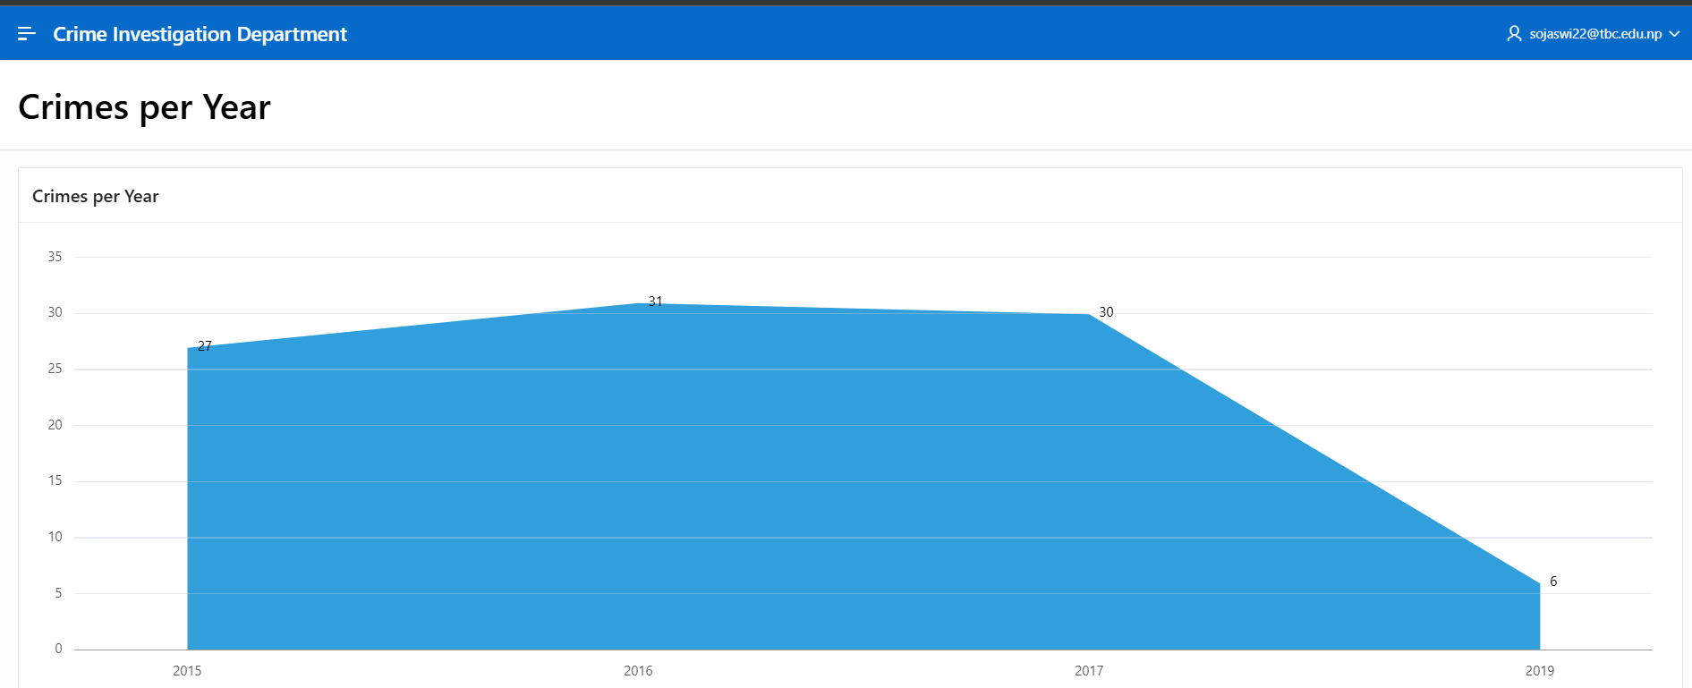
Fig 12: Number of Crimes Per Year
Chart Explanation:
The above chart shows total number of crimes reported each year, with the filled area prioritizing changes in crime volume over years. An expanding area depicts rising crime levels, while shrinking area reflects decrement. Nearly equal height lining from 2016 and 2017 shows more than 30 crimes in both years whereas in 2019, the decline indicates the lower rate of crimes up to only 6 crimes in that year.
How the Chart or Report helps the Police and Crime Investigation
- Risk Evaluation and Preparation:
The report allows us to identify years with strangely high crime numbers which might signal social or economic problems. This insight aids police officers for early preparation of prevention policies.
- Strategic Resource Forecasting:
It supports budget allocation, staffing and infrastructure planning based on the long-term trends in crime rise in recent years. Increasing patterns indicate the need to expand resources.

- Long-Term Trend Analysis:
It helps police officers to understand whether crime is rising, falling or remaining stable over multiple years by using long-term trend analysis. This enables strategic planning for crime prevention in near future.

